Supplemental materials
Table of contents
1. Study protocol
- Search terms
2. Network plots
- S1 Figure
3. Inconsistency plots
- S2 Figure
4. Contribution plots
- S3 Figure
5. Rankograms
- S4 Figure
6. Cumulative ranking curve plots
- S5 Figure
7. SUCRA mean ranking plots
- S6 Figure
8. Predictive interval plots
- S7 Figure
9. Comparison-adjusted funnel plots
- S8 Figure
10. SUCRA values
- S9 Table
11. pH of umbilical artery and vein
- S10 Table

1. Study protocol
Inclusion and exclusion criteria
We propose to include only randomized controlled trials (RCTs) comparing two or more vasopressors for the management of maternal hypotension during cesarean section under spinal anesthesia
The PICO-SD information are as follows: patients (P): All parturient receiving cesarean section under spinal anesthesia, intervention (I): use of vasopressors to treat or prevent hypotension in parturients receiving cesarean section, (C): other vasopressors or placebo or no treatment, outcome measures (O): the primary outcomes will be systolic blood pressure measured early (0-20 minutes) and middle (20 minutes - 1 hour) phase of cesarean section, maximum and mimimum systolic blood pressure during the caesarean section, incidence of hypertension and hypotension during the caesarean section, incidence of fetal acidosis at umbilical artery or vein and pH at umbilical artery or vein. The secondary outcomes will be incidence of bradycardia and tachycardia during the caesarean section, incidence of nausea, vomiting, nausea and vomiting after caesarean section, mean arterial pressure and heart rate, during the caesarean section and fetal APGAR score, and study design (SD): RCT.
The exclusion criteria will be as follows: 1) review articles, case reports, case-series, letters to the editor, commentaries, proceedings, laboratory science studies, and any other non-relevant studies, and 2) studies that did not report the outcomes of interest. There will be neither language limitations nor date restrictions in our study.

Information sources
Electronic search. We propose to search MEDLINE, EMBASE, the Cochrane Central Register of Controlled Trials (CENTRAL) and Google scholar using search terms related to vasopressors for the management of maternal hypotension during cesarean section under spinal anesthesia. Search terms to be used for MEDLINE and EMBASE are presented in the Appendix. Two authors will screen titles and abstracts of the retrieved articles. Reference lists will be imported to Endnote software 8.1 (Thompson Reuters, CA, USA) and duplicate articles will be removed. Additional relevant articles will be identified by scanning reference lists of articles obtained from the original search.

Search terms for MEDLINE
- randomized controlled trial.pt
- randomized controlled trial$.mp
- controlled clinical trial.pt
- controlled clinical trial$.mp
- random allocation.mp
- exp double-blind method/
- double-blind.mp
- exp single-blind method/
- single-blind.mp
- or/1-9
- clinical trial.pt
- clinical trial$.mp
- exp clinical trial/
- (clin$ adj25 trial$).mp
- ((singl$ or doubl$ or tripl$ or trebl$) adj25 (blind$ or mask$)).mp
- random$.mp
- exp research design/
- research design.mp
- or/11-18
- 10 or 19
- Case report.tw.
- Letter.pt.
- Historical article.pt.
- Review.pt.
- or/21-24
- 20 not 25
- Exp Cesarean Section/
- Caesarean section.mp
- Cesarean delivery.mp
- Cesaerean deliver.mp.
- C-section.mp
- C section.mp
- C-sections.mp
- Abdominal delivery.mp
- Abdominal deliveries.mp
- Delivery, abdominal.mp
- Or/27-36
- Exp Anesthesia, spinal/
- Spinal anesthesia.mp
- Spinal anaesthesia.mp
- Subarachnoid block.mp
- Subarachnoid anesthesia.mp
- Subarachinoid anaesthesia.mp
- Axial anesthesia.mp
- Axial anaestheia.mp
- Exp Anesthesia, conduction/
- Or/38-46
- 37 and 47
- 26 and 48
- Exp vasoconstrictor agents/
- Vasoconstrictor.mp
- Vasopressor.mp
- Vasoacitve.mp
- Exp ephedrine/
- Ephedrine.mp
- Sal-phedrine/
- Sal Phedrine/
- Salphedrine
- Ephedrine sulphate/
- Ephedrine hydrochloride/
- Ephedrine renaudin/
- Exp metaraminol/
- Meta-hydroxynorephedrine/
- Metaradrin/
- Isophenlyephrine/
- Aramine/
- Araminol/
- Mephentermine/
- Exp phenylephrine/
- Phenylephrine.mp
- Metasympatol/
- Mezaton/
- Metaoxedrine
- Neo-Synephrine/
- Neo Synephrine/
- Neosynephrine/
- Exp methoxamine/
- Methoxamine.mp
- Methoxamedrin/
- Vasylox/
- Vasoxine/
- Vasoxin/
- Vasoxyl/
- Exp norepinephrine/
- Norepinephrine/
- Noradrenaline/
- Levarterenol/
- Levonorepinephrine/
- Levonor/
- Levophed/
- Arterenol/
- Exp epinephrine/
- Epinephrine.mp
- Adrenaline/
- Epitrate/
- Lyophrin/
- Epifrin/
- Or/50-97
- 49 and 98
Search terms for Embase
- randomi?ed controlled trial$.mp.
- 'controlled clinical trial (topic)'/exp
- controlled AND clinical AND trials
- controlled clinical trial$.mp.
- 'randomization'/exp
- 'random allocation'/exp
- random allocation.mp.
- double-blind.mp.
- single-blind.mp.
- #1 OR #2 OR #3 OR #4 OR #5 OR #6 OR #7 OR #8 OR #9
- 'clinical trial (topic)'/exp
- clinical AND trial$.mp.
- random$.mp.
- rct
- #11 OR #12 OR #13 OR #14
- #10 OR #15
- 'case study'/exp
- 'case report'/exp
- 'abstract report'/exp
- 'letter'/exp
- #17 OR #18 OR #19 OR #20
- #16 NOT #21
- 'cesarean section'/exp
- Caesarean section.mp
- Cesarean delivery.mp
- Cesaerean delivery.mp.
- C-section.mp
- C section.mp
- C-sections.mp
- abdominal AND delivery.mp
- #23 OR #24 OR #25 OR #26 OR #27 OR #28 OR #29 OR #30
- 'spinal anesthesia'/exp
- spinal AND anesthesia
- spinal AND anaesthesia
- subarachnoid AND block
- Subarachnoid anesthesia
- subarachinoid AND anaesthesia
- axial AND anesthesia
- axial AND anaestheia
- #32 OR #33 OR #34 OR #35 OR #36 OR #37 OR #38 OR #39
- #31 AND #40
- #22 AND #41
- 'hypertensive agent'/exp
- Vasoconstrictor
- Vasopressor
- Vasoacitve
- 'ephedrine'/exp
- Ephedrine
- Sal-phedrine
- Sal Phedrine
- Salphedrine
- 'metaraminol'/exp
- Meta-hydroxynorephedrine
- Metaradrin
- Isophenlyephrine
- Aramine
- Araminol
- Mephentermine
- 'phenylephrine'/exp
- Phenylephrine
- Metasympatol
- Mezaton
- Metaoxedrine
- Neo-Synephrine
- Neosynephrine
- 'methoxamine'/exp
- Methoxamine
- Methoxamedrin
- Vasylox
- Vasoxine
- Vasoxin
- Vasoxyl
- 'noradrenalin'/exp
- Norepinephrine
- Noradrenaline
- Levarterenol
- Levonorepinephrine
- Levonor
- Levophed
- Arterenol
- 'epinephrine'/exp
- Epinephrine
- Adrenaline
- Epitrate
- Lyophrin
- Epifrin
- #43 OR #44 OR #45 OR #46 OR #47 OR #48 OR #49 OR #50 OR #51 OR #52 OR #53 OR #54 OR #55 OR #56 OR #57 OR #58 OR #59 OR #60 OR #61 OR #62 OR #63 OR #64 OR #65 OR #66 OR #67 OR #68 OR #69 OR #70 OR #71 OR #72 OR #73 OR #74 OR #75 OR #76 OR #77 OR #78 OR #79 OR #80 OR #81 OR #82 OR #83 OR #84 OR #85 OR #86
- #42 AND #87
Search terms for Cochrane Central Register of Controlled Trials (CENTRAL)

1. MeSH descriptor Cesarean Section explode all trees
2. Caesarean section.ti,ab,kw.
3. Cesarean delivery.ti,ab,kw.
4. Cesaerean delivery.ti,ab,kw.
5. C-section.ti,ab,kw.
6. C section.ti,ab,kw.
7. C-sections.ti,ab,kw.
8.( abdominal AND delivery).ti,ab,kw.
9. #1 OR #2 OR #3 OR #4 OR #5 OR #6 OR #7 OR #8
10. MeSH descriptor Hypertensive Agent explode all trees
11. Vasoconstrictor.ti,ab,kw.
12. Vasopressor.ti,ab,kw.
13. Vasoacitve.ti,ab,kw.
14. MeSH descriptor Ephedrine explode all trees
15. Ephedrine.ti,ab,kw.
16. Sal-phedrine.ti,ab,kw.
17. Sal Phedrine.ti,ab,kw.
18. Salphedrine.ti,ab,kw.
19 MeSH descriptor Metaraminoexplode all trees
20. Meta-hydroxynorephedrine.ti,ab,kw.
21. Metaradrin.ti,ab,kw.
22. Isophenlyephrine.ti,ab,kw.
23. Aramine
24. Araminol.ti,ab,kw.
25. Mephentermine.ti,ab,kw.
26. MeSH descriptor Phenylephrine explode all trees
27. Phenylephrine.ti,ab,kw.
28. Metasympatol.ti,ab,kw.
29. Mezaton.ti,ab,kw.
30. Metaoxedrine.ti,ab,kw.
31. Neo-Synephrine.ti,ab,kw.
32. Neosynephrine.ti,ab,kw.
33. MeSH descriptor Methoxamine explode all trees
34. Methoxamine.ti,ab,kw.
35. Methoxamedrin.ti,ab,kw.
36. Vasylox.ti,ab,kw.
37. Vasoxine.ti,ab,kw.
38. Vasoxin.ti,ab,kw.
39. Vasoxyl.ti,ab,kw.
40. MeSH descriptor Noradrenalin explode all trees
41. Norepinephrine.ti,ab,kw.
42. Noradrenaline.ti,ab,kw.
43. Levarterenol.ti,ab,kw.
44. Levonorepinephrine.ti,ab,kw.
45. Levonor.ti,ab,kw.
46. Levophed.ti,ab,kw.
47. Arterenol.ti,ab,kw.
48. MeSH descriptor Epinephrine explode all trees
49. Epinephrine.ti,ab,kw.
50. Adrenaline.ti,ab,kw.
51. Epitrate.ti,ab,kw.
52. Lyophrin.ti,ab,kw.
53. Epifrin.ti,ab,kw.
54. #11 OR #12 OR #13 OR #14 OR #15 OR #16 OR #17 OR #18 OR #19 OR #20 OR #21 OR #22 OR #23 OR #24 OR #25 OR #26 OR #27 OR #28 OR #29 OR #30 OR #31 OR #32 OR #33 OR #34 OR #35 OR #36 OR #37 OR #38 OR #39 OR #40 OR #41 OR #42 OR #43 OR #44 OR #45 OR #46 OR #47 OR #48 OR #49 OR #50 OR #51 OR #52 OR #53
55. #9 AND #54

Search term for Google

Google search was performed manually using the related term ‘randomized controlled trial’, ‘caesarean section’, ‘spinal anesthesia’, ‘vasopressor’ and their combination.

2. Network plots
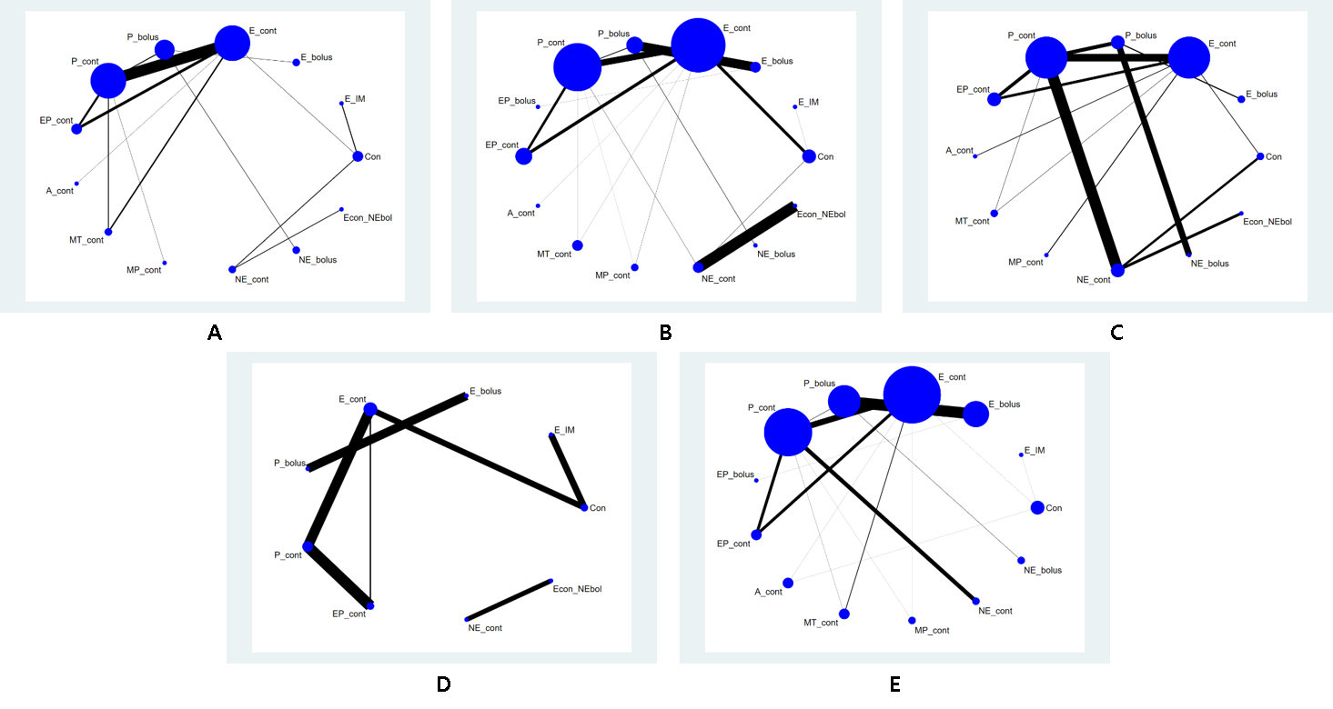
S1 Figure. Network plots. (A) Incidence of hypertension, (B) Maximum systolic blood pressure (SBP_{max}), (C) Incidence of bradycardia, (D) Incidence of tachycardia, (E) Umbilical venous pH. Abbreviations: E = ephedrine; P = phenylephrine; EP = ephedrine mixed with phenylephrine; A II = angiotensin II; MT = metaraminol; MP = mephentermine; NE = norepinephrine.
3. Inconsistency plots

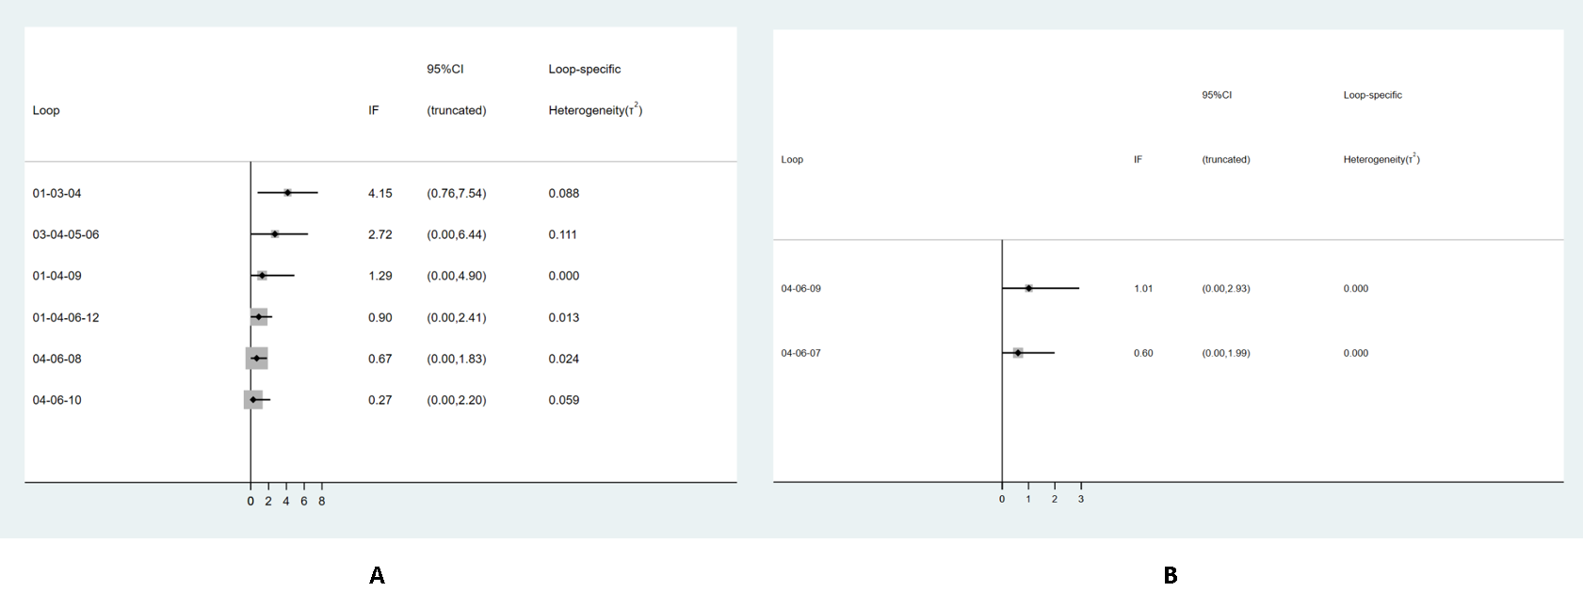
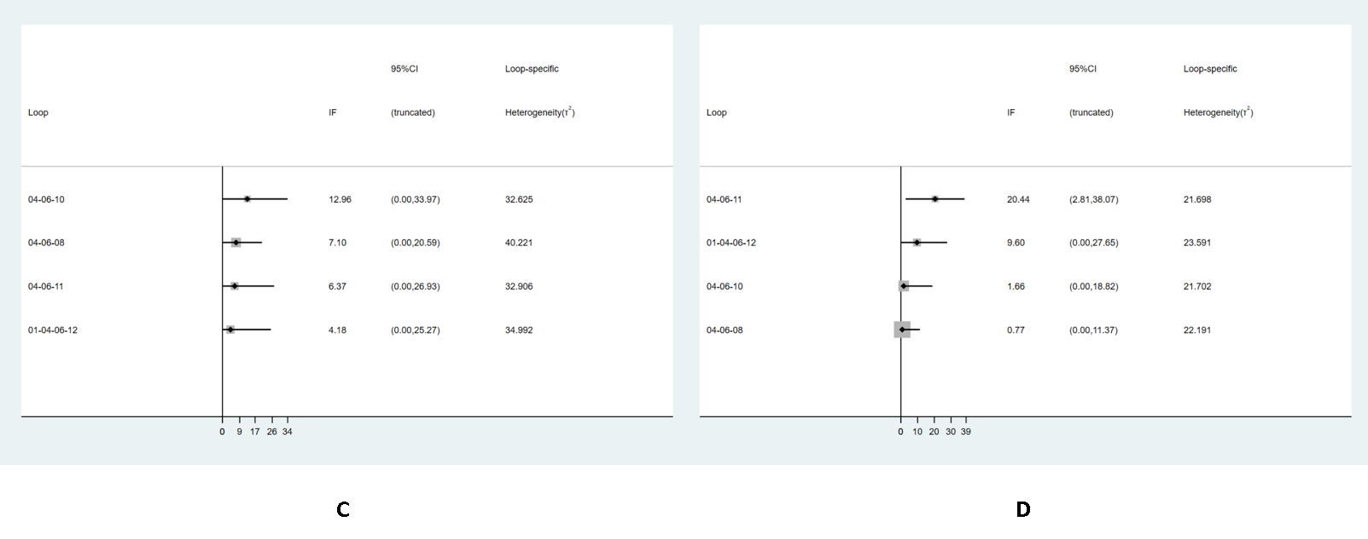
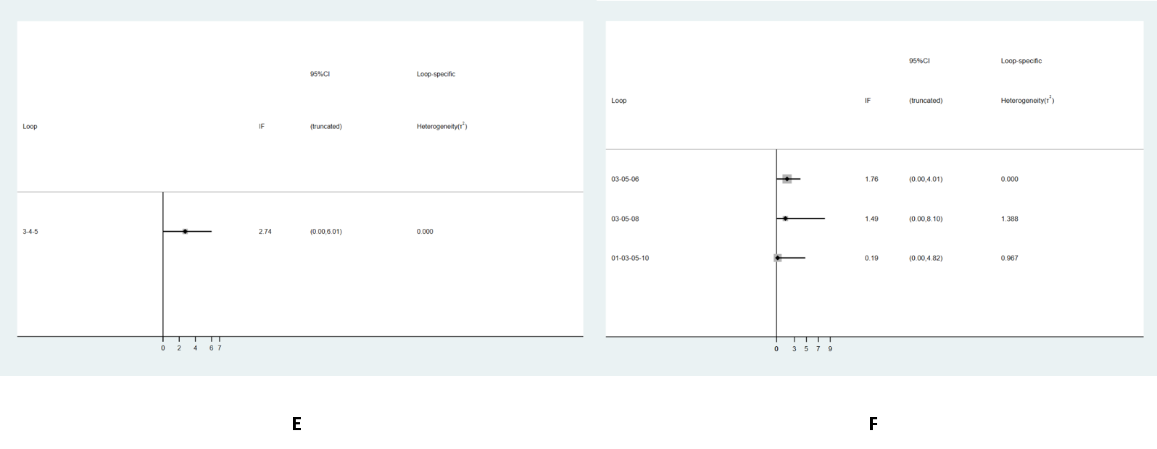
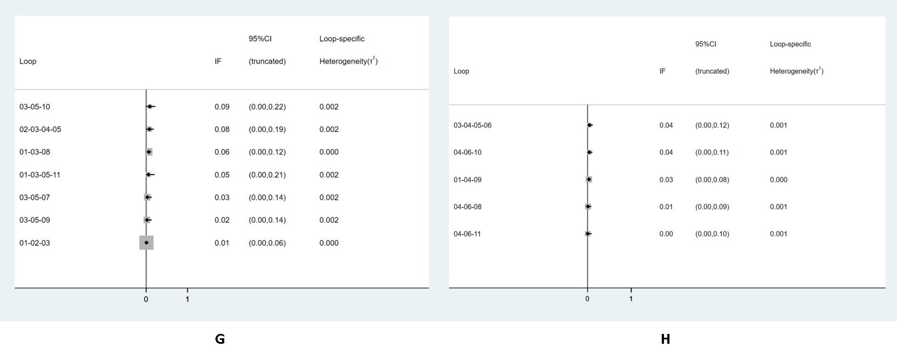
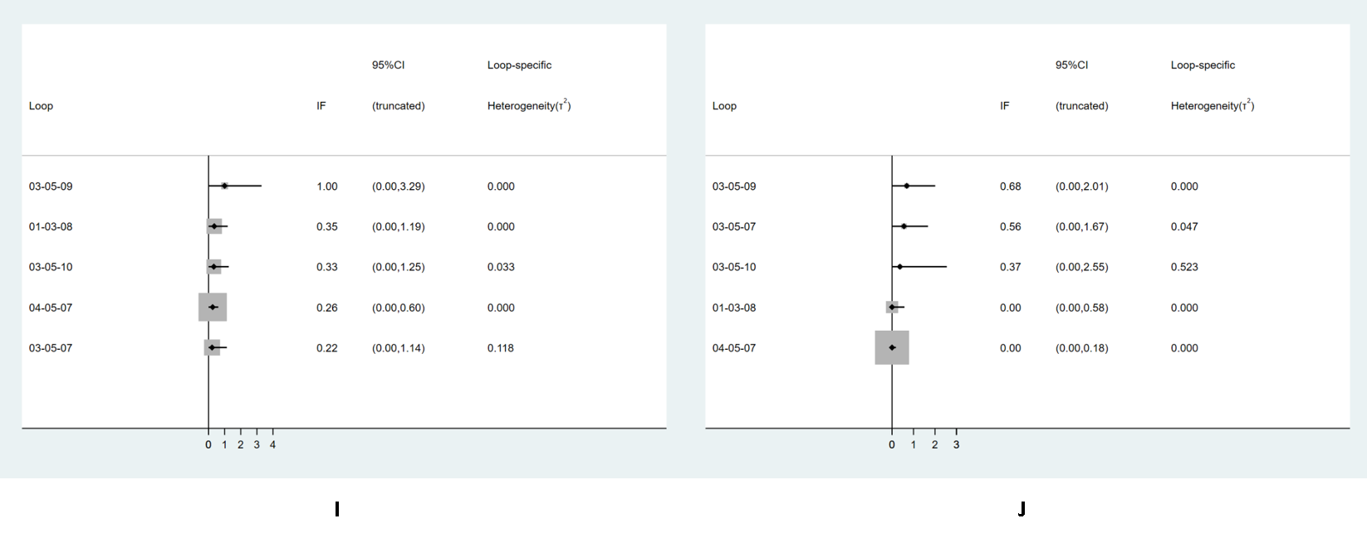
S2 Figure. Inconsistency plots. (A) Incidence of Hypotension, (B) Incidence of hypertension, (C) Minimum systolic blood pressure (SBP_{min}) (D) Maximum systolic blood pressure (SBP_{max}), (E) Incidence of tachycardia, (F) Incidence of bradycardia, (G) Umbilical arterial pH, (H) Umbilical venous pH, (I) 1 min Apgar score, (J) 5 min Apgar score.

4. Contribution plots
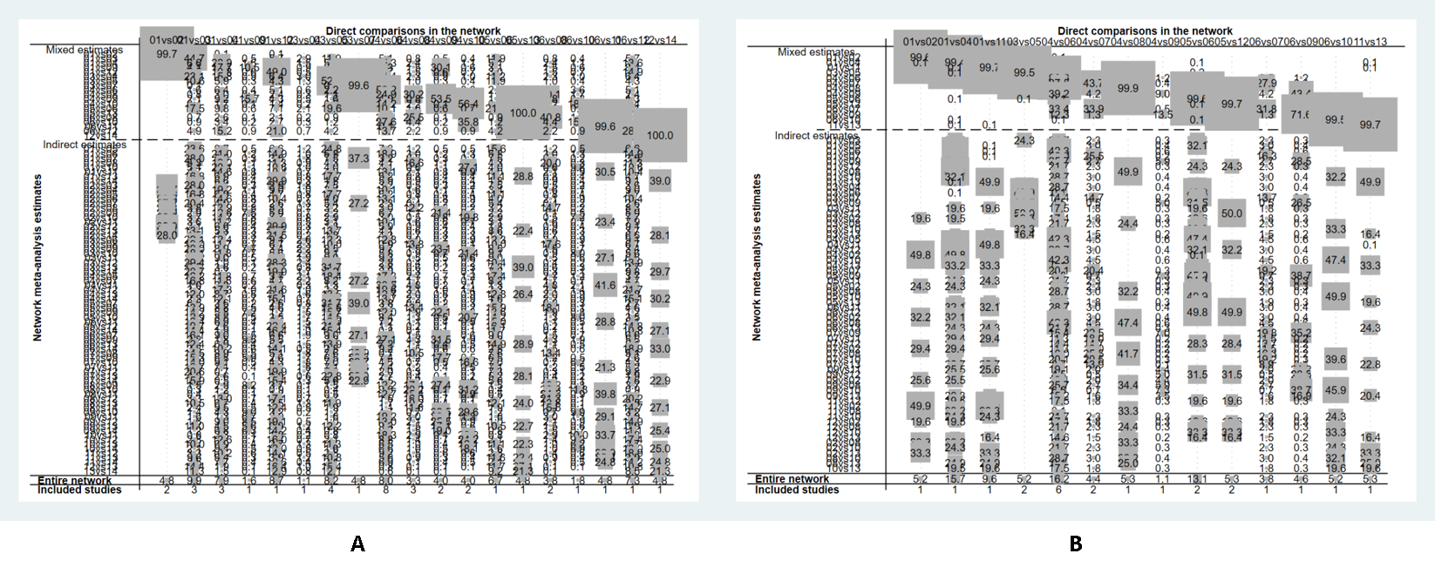
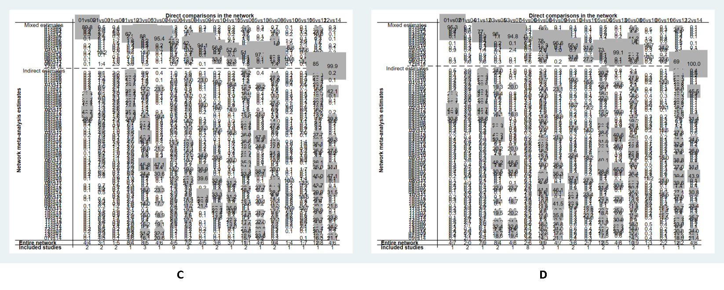

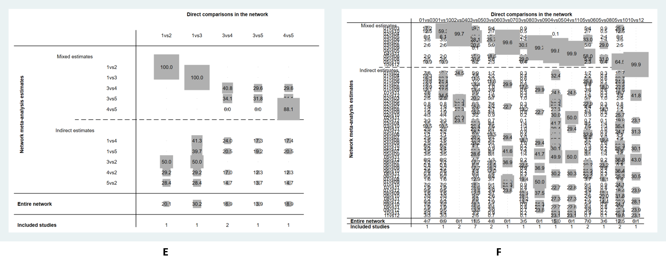

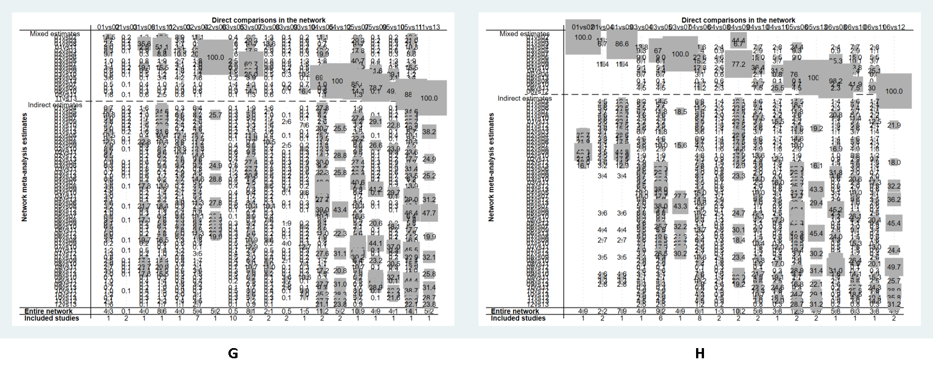

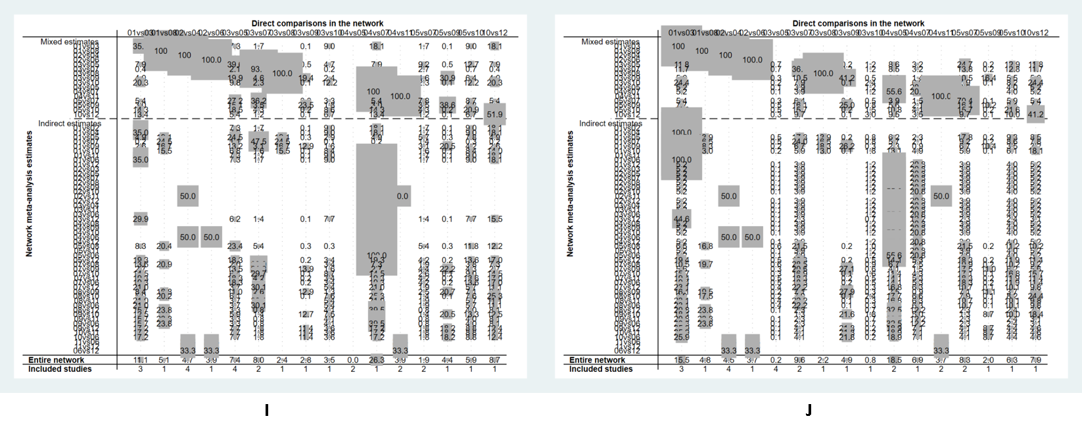
S3 Figure. Contribution plots. (A) Incidence of Hypotension, (B) Incidence of hypertension, (C) Minimum systolic blood pressure (SBP_{min}) (D) Maximum systolic blood pressure (SBP_{max}), (E) Incidence of tachycardia, (F) Incidence of bradycardia, (G) Umbilical arterial pH, (H) Umbilical venous pH, (I) 1 min Apgar score, (J) 5 min Apgar score.

5. Rankograms
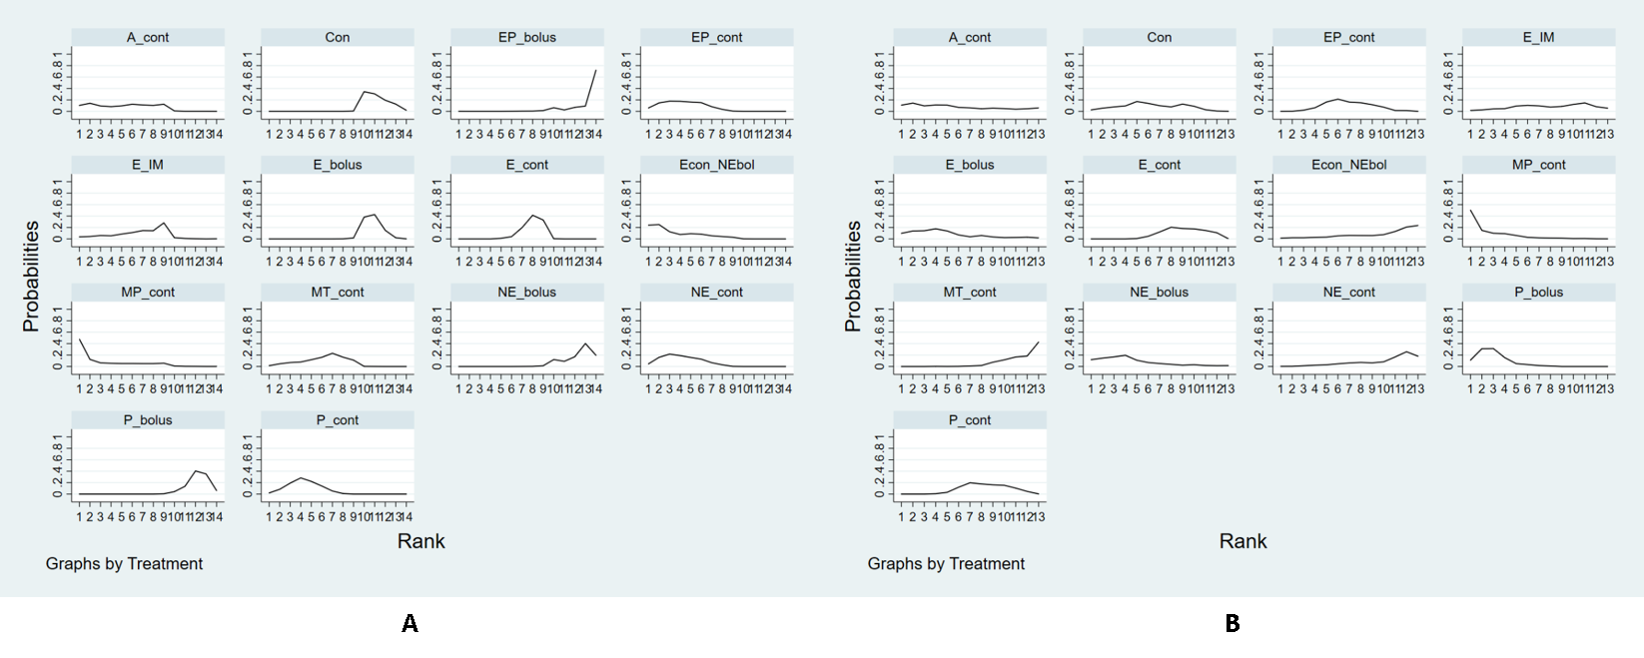
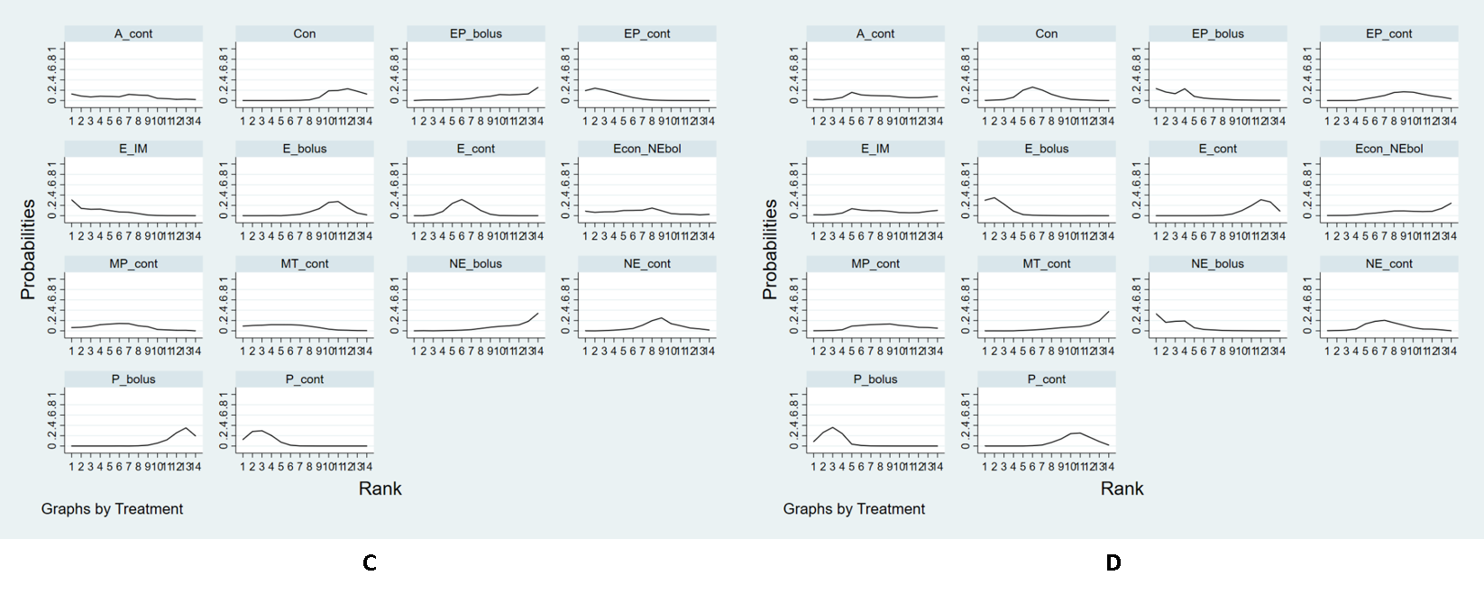
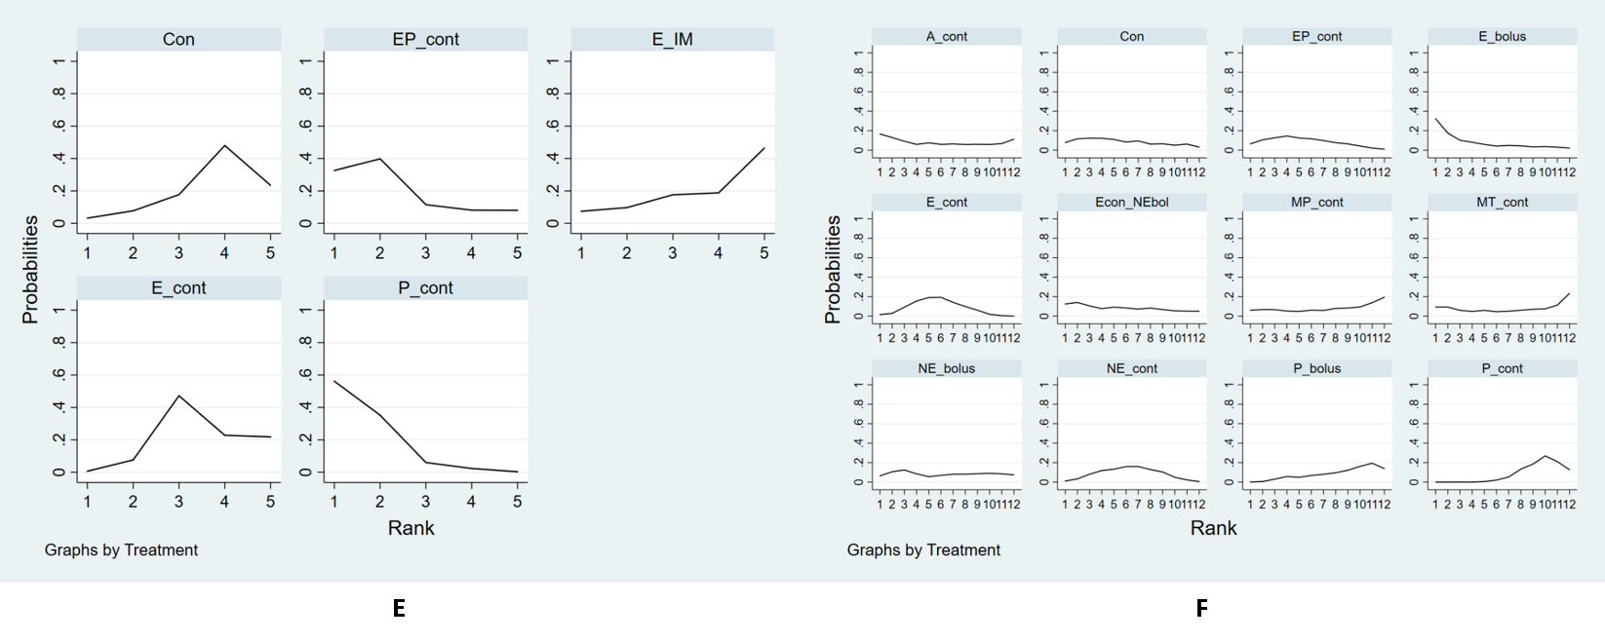
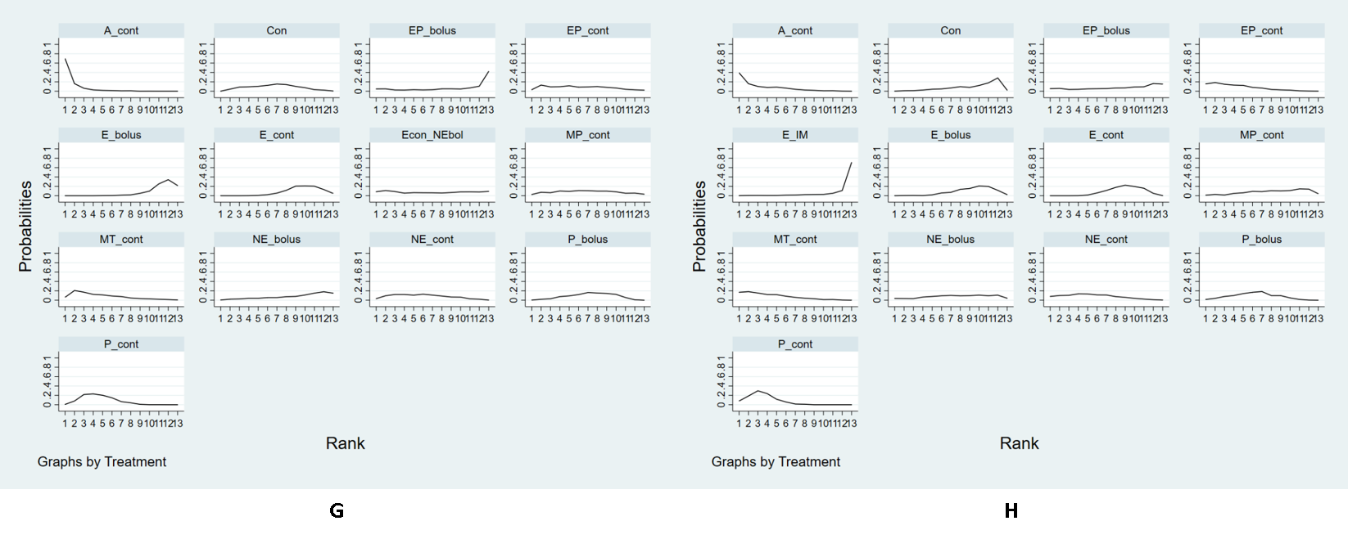
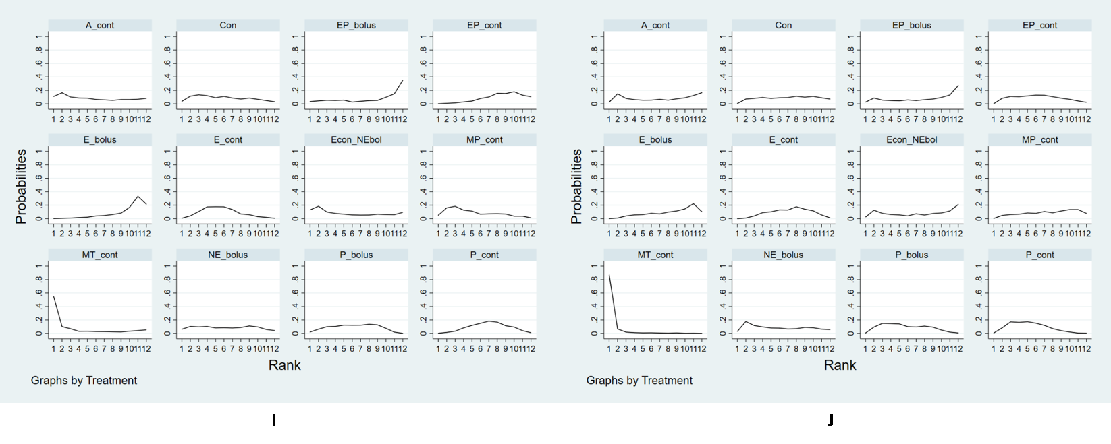
S4 Figure. Rankograms. (A) Incidence of Hypotension, (B) Incidence of hypertension, (C) Minimum systolic blood pressure (SBP_{min}) (D) Maximum systolic blood pressure (SBP_{max}), (E) Incidence of tachycardia, (F) Incidence of bradycardia, (G) Umbilical arterial pH, (H) Umbilical venous pH, (I) 1 min Apgar score, (J) 5 min Apgar score. Abbreviations: E = ephedrine; P = phenylephrine; EP = ephedrine mixed with phenylephrine; A II = angiotensin II; MT = metaraminol; MP = mephentermine; NE = norepinephrine.

6. Cumulative ranking curve plots
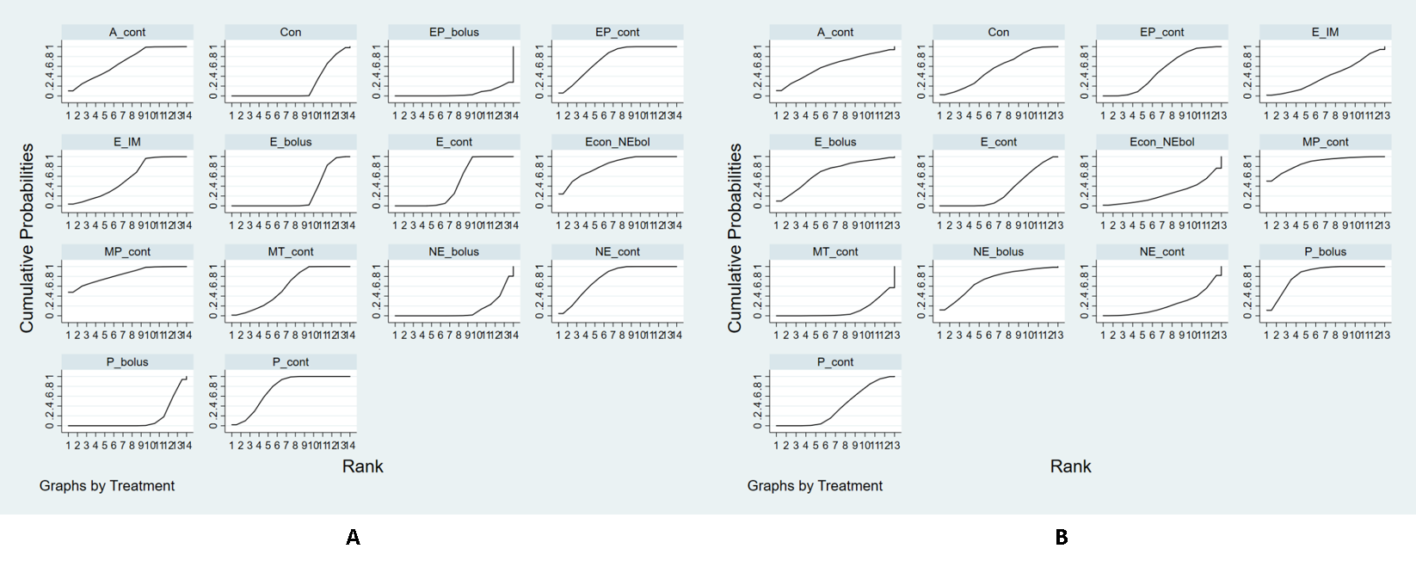
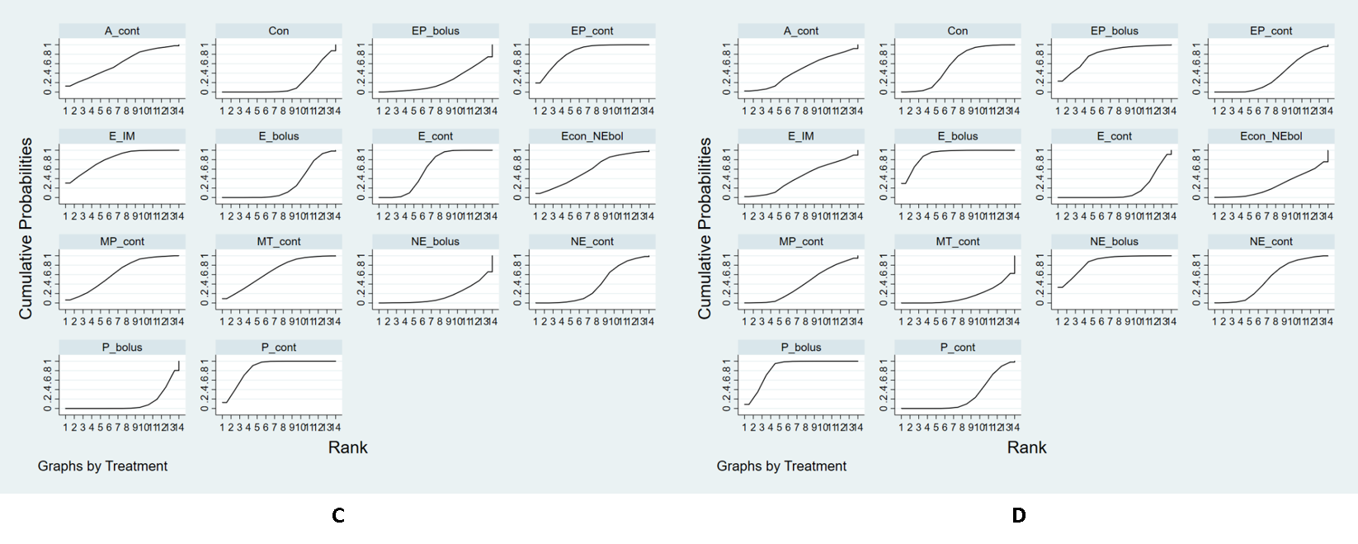
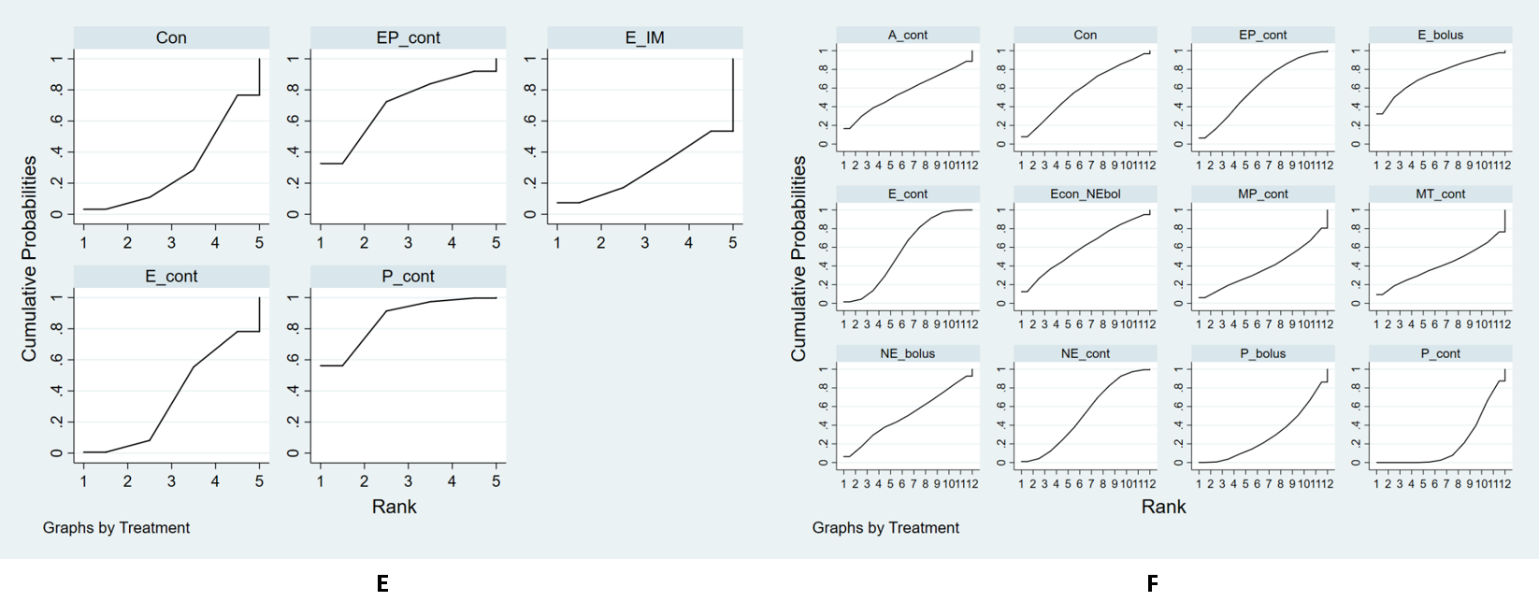
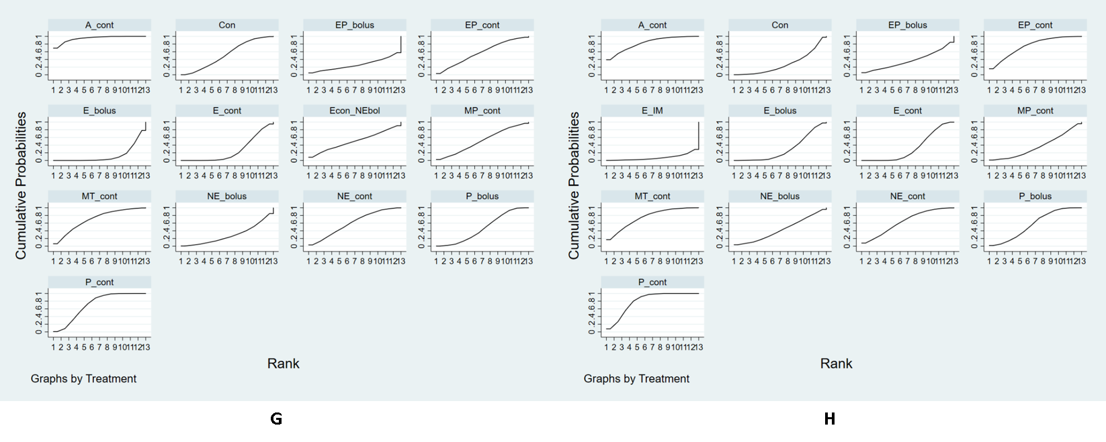
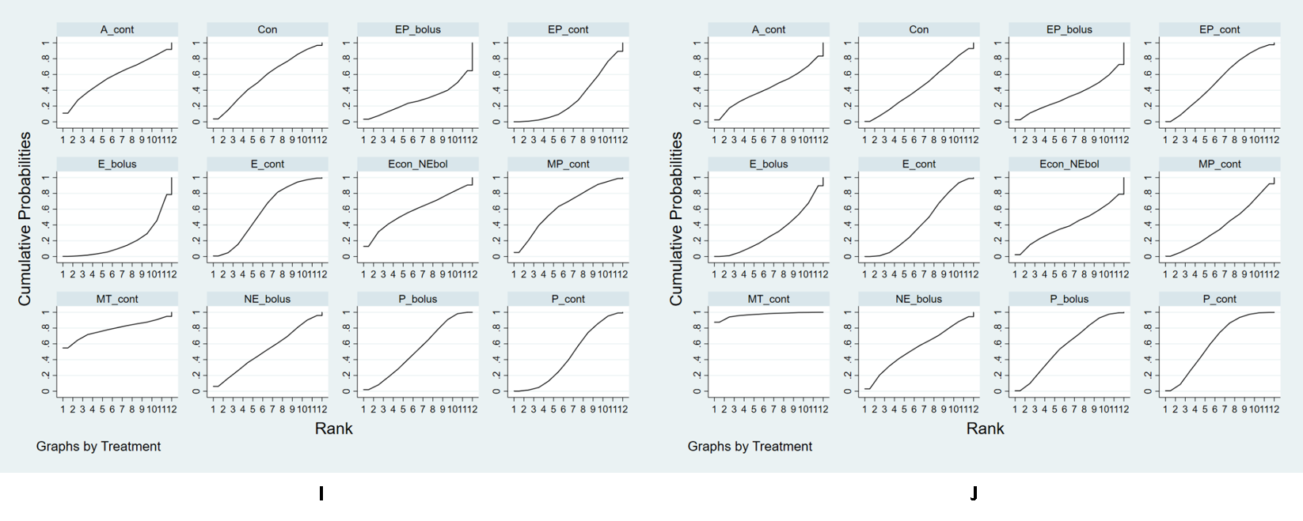
S5 Figure. Cumulative ranking curve plots. (A) Incidence of Hypotension, (B) Incidence of hypertension, (C) Minimum systolic blood pressure (SBP_{min}) (D) Maximum systolic blood pressure (SBP_{max}), (E) Incidence of tachycardia, (F) Incidence of bradycardia, (G) Umbilical arterial pH, (H) Umbilical venous pH, (I) 1 min Apgar score, (J) 5 min Apgar score. Abbreviations: E = ephedrine; P = phenylephrine; EP = ephedrine mixed with phenylephrine; A II = angiotensin II; MT = metaraminol; MP = mephentermine; NE = norepinephrine.

7. SUCRA mean ranking plots
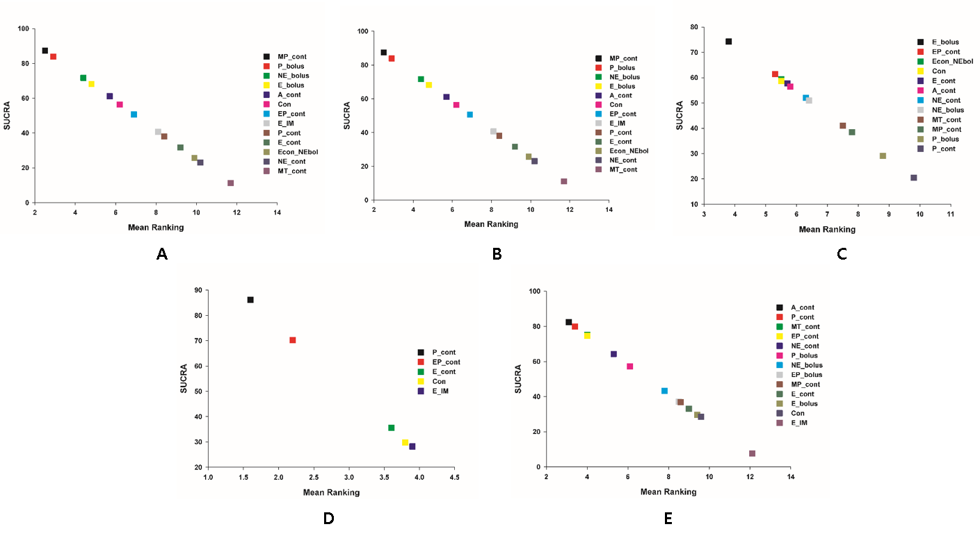
S6 Figure. SUCRA mean ranking plots. (A) Incidence of hypertension, (B) Maximum systolic blood pressure (SBP_{max}), (C) Incidence of bradycardia, (D) Incidence of tachycardia, (E) Umbilical venous pH. Abbreviations: E = ephedrine; P = phenylephrine; EP = ephedrine mixed with phenylephrine; A II = angiotensin II; MT = metaraminol; MP = mephentermine; NE = norepinephrine.

8. Predictive interval plots
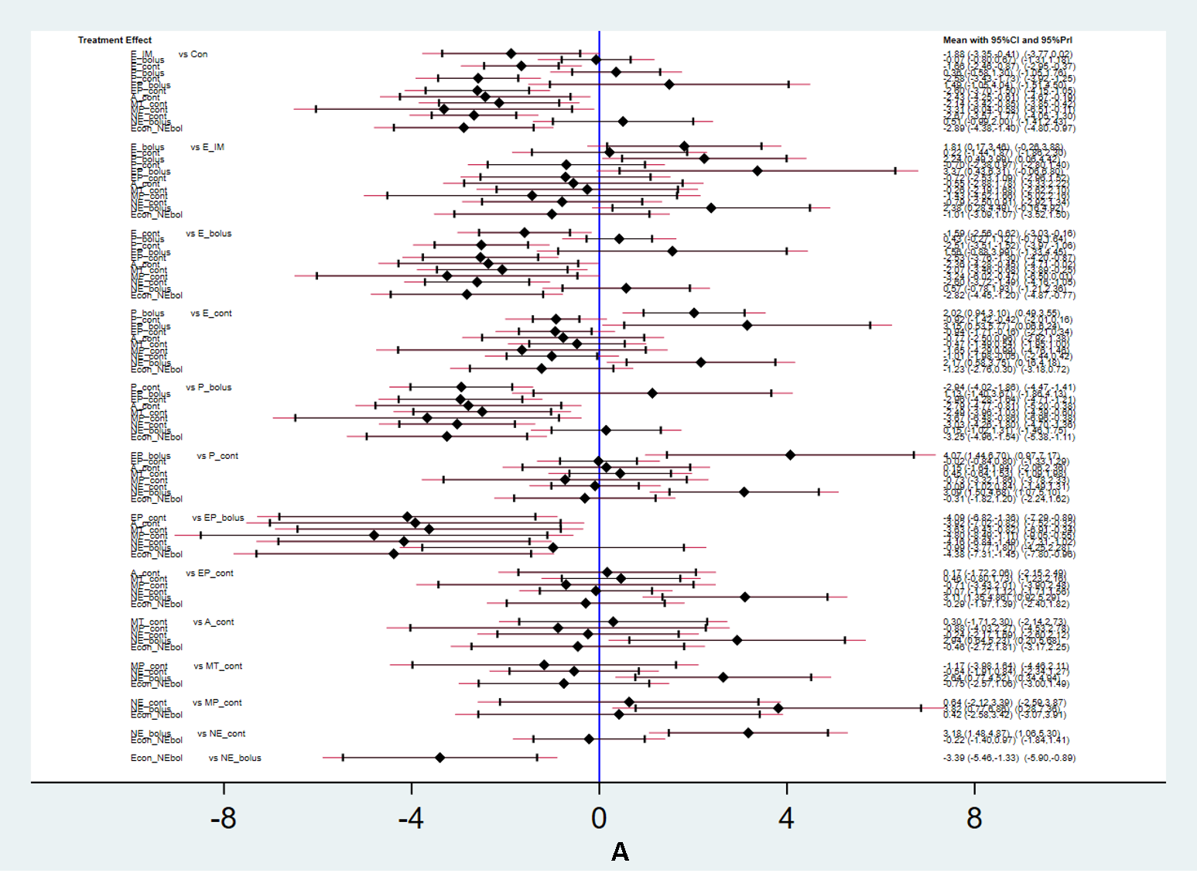
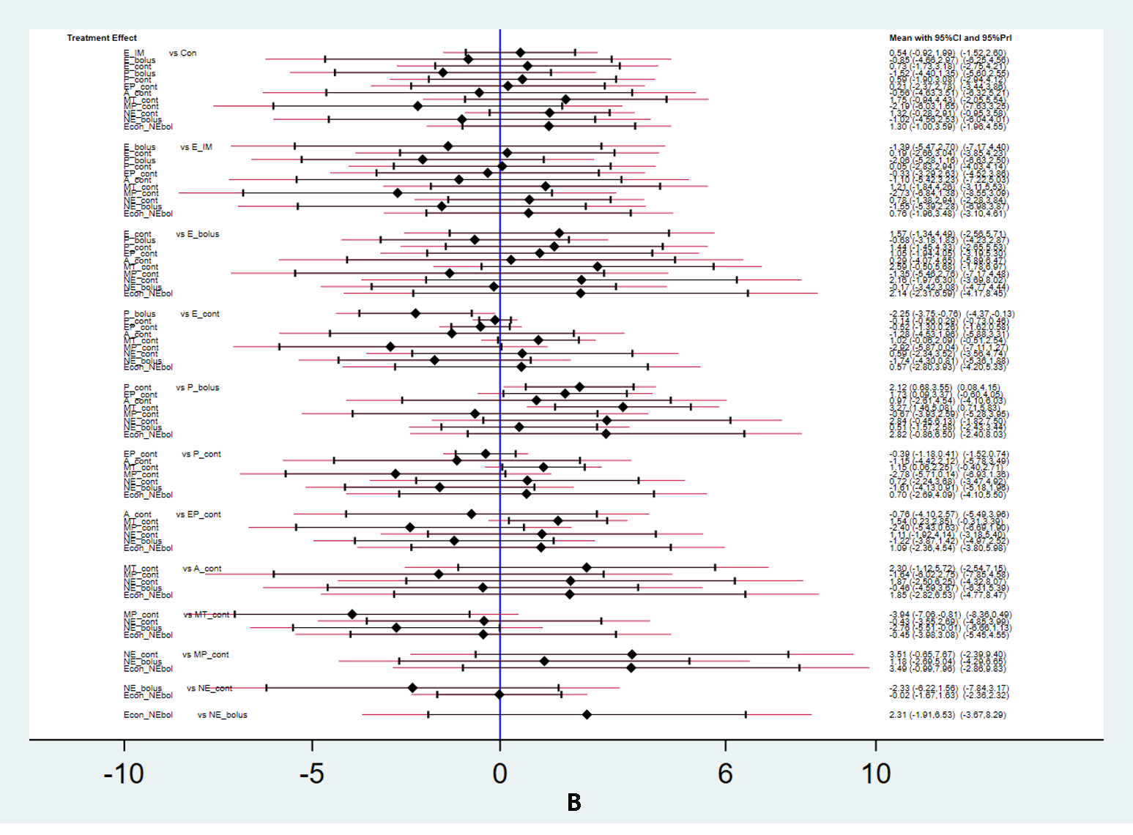
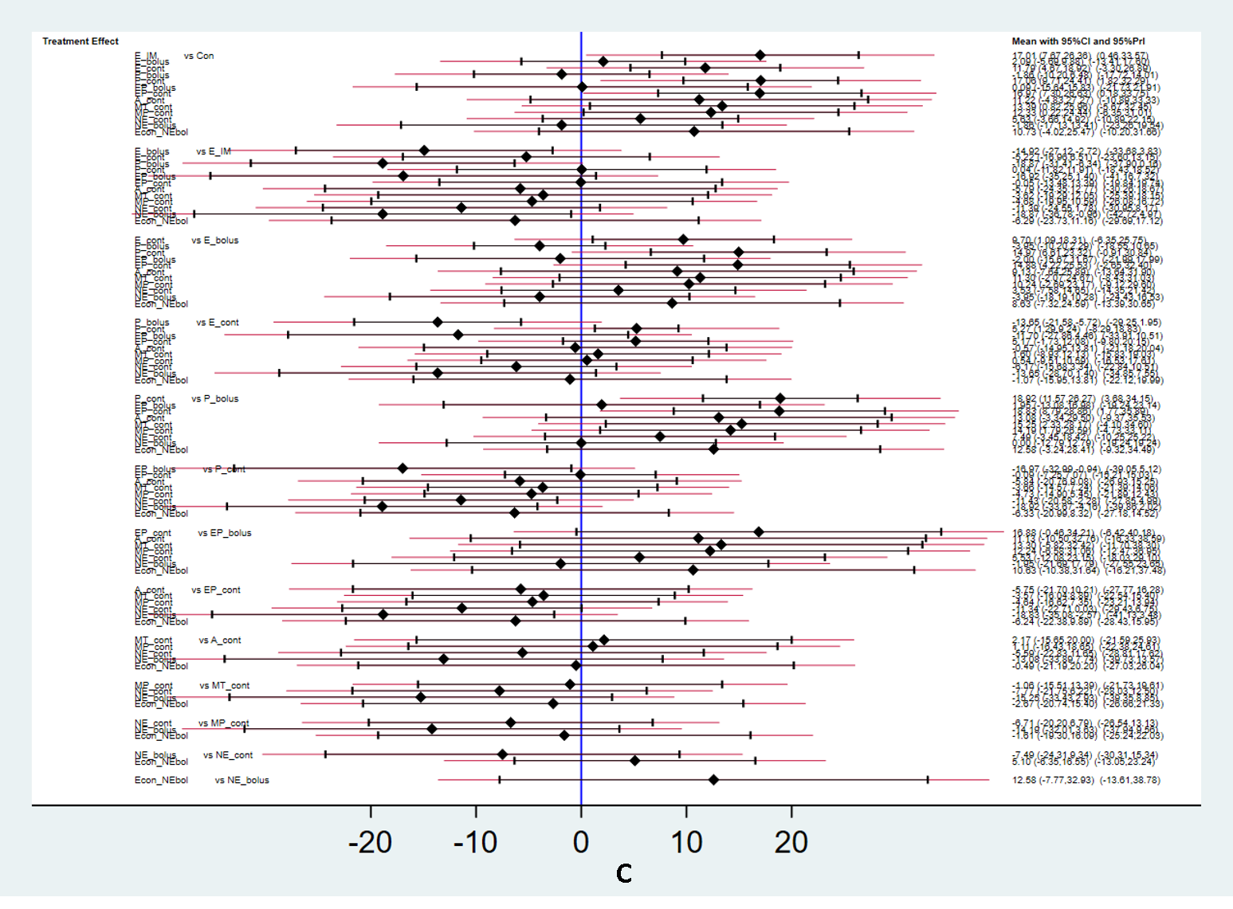
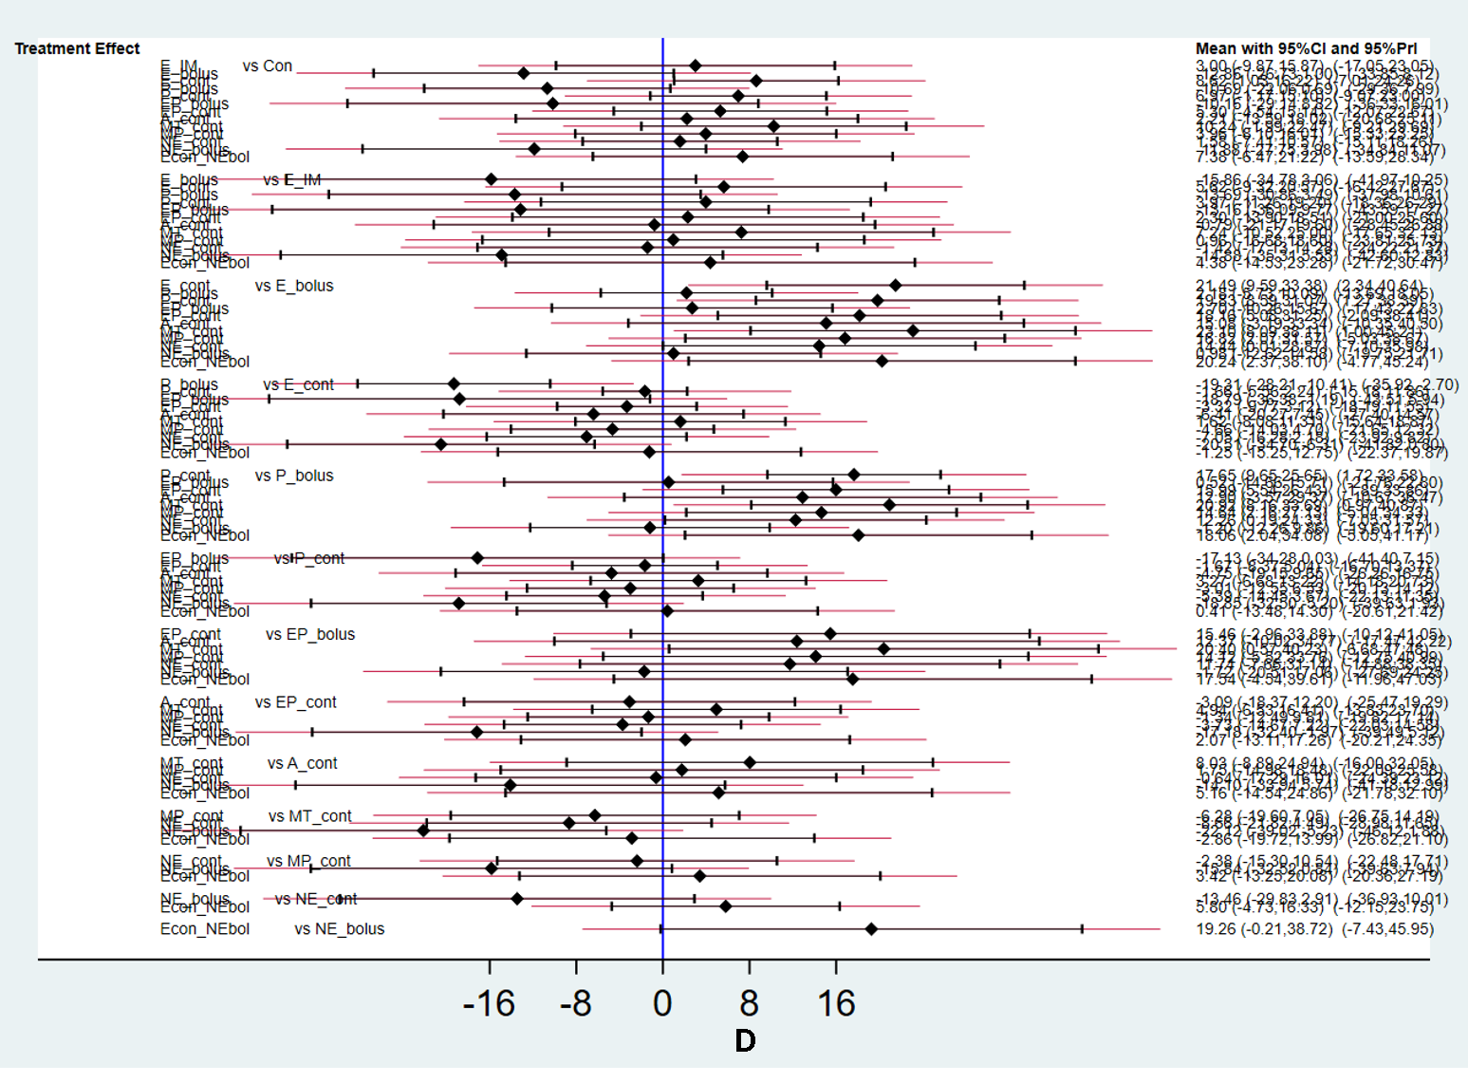
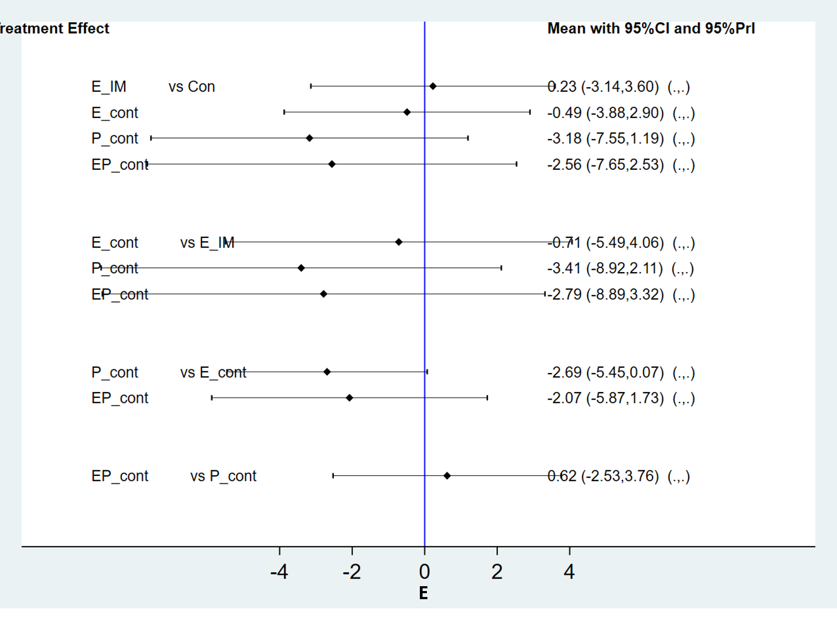
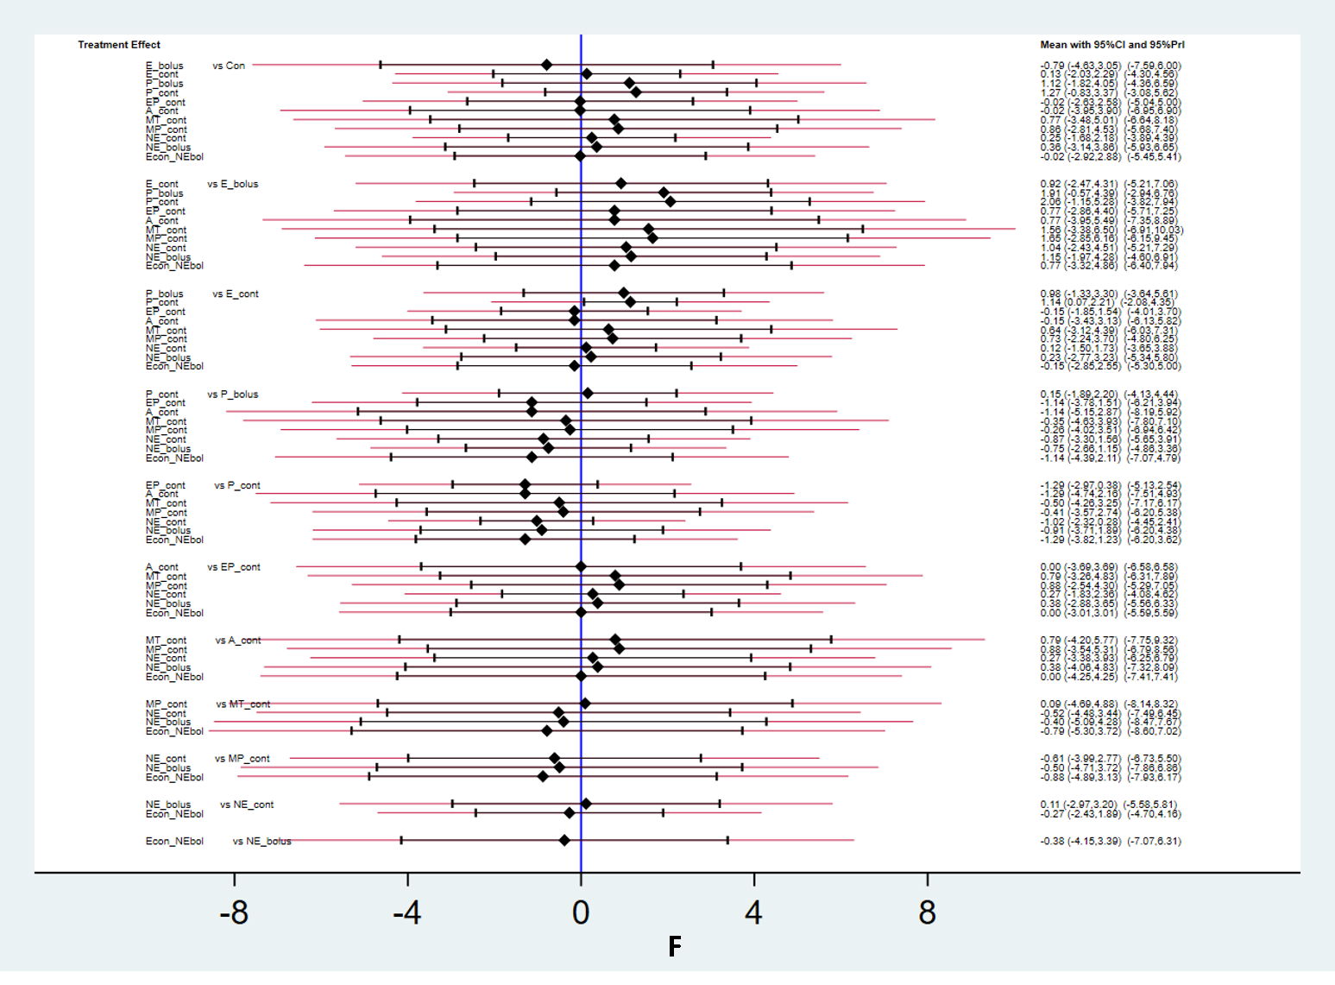
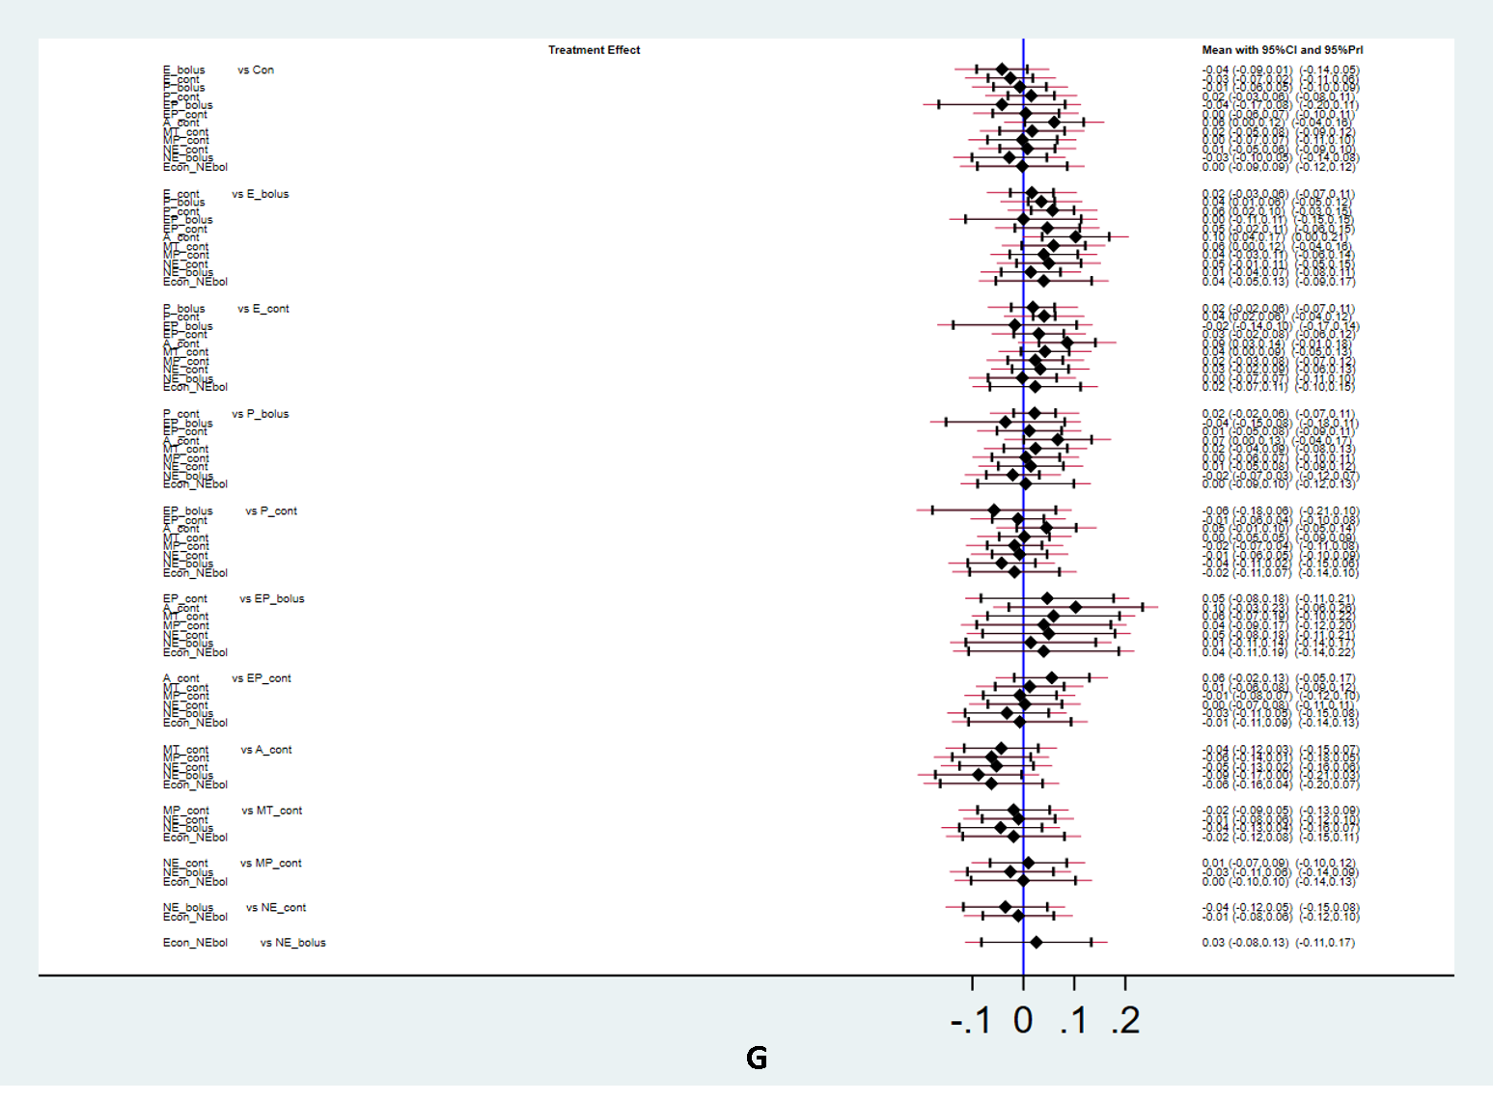
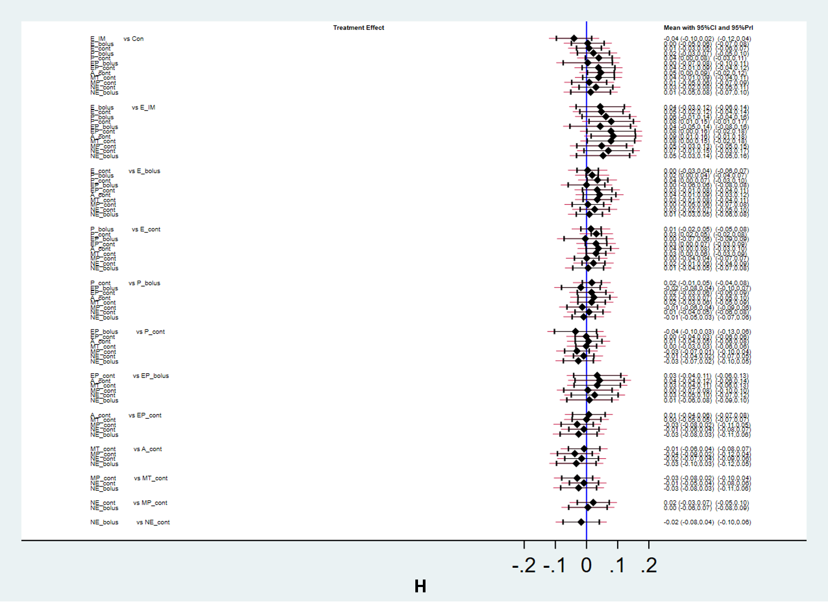
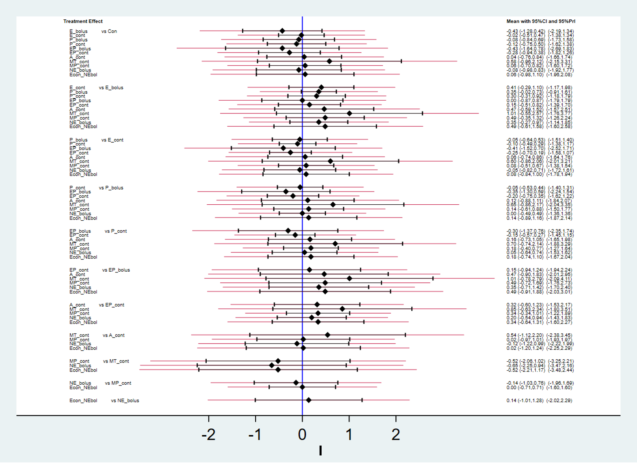
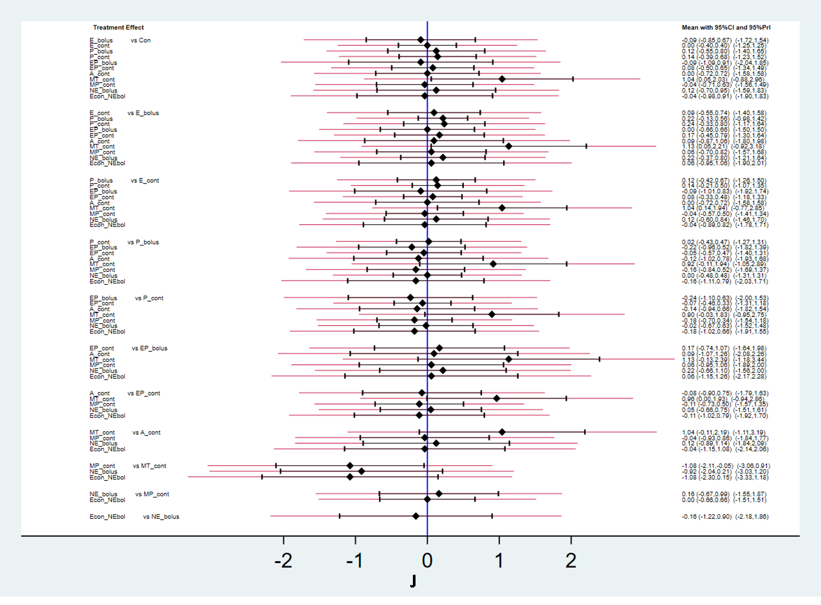
S7 Figure. Predictive interval plots. (A) Incidence of Hypotension, (B) Incidence of hypertension, (C) Minimum systolic blood pressure (SBP_{min}) (D) Maximum systolic blood pressure (SBP_{max}), (E) Incidence of tachycardia, (F) Incidence of bradycardia, (G) Umbilical arterial pH, (H) Umbilical venous pH, (I) 1 min Apgar score, (J) 5 min Apgar score. Abbreviations: E = ephedrine; P = phenylephrine; EP = ephedrine mixed with phenylephrine; A II = angiotensin II; MT = metaraminol; MP = mephentermine; NE = norepinephrine.

9. Comparison-adjusted funnel plots
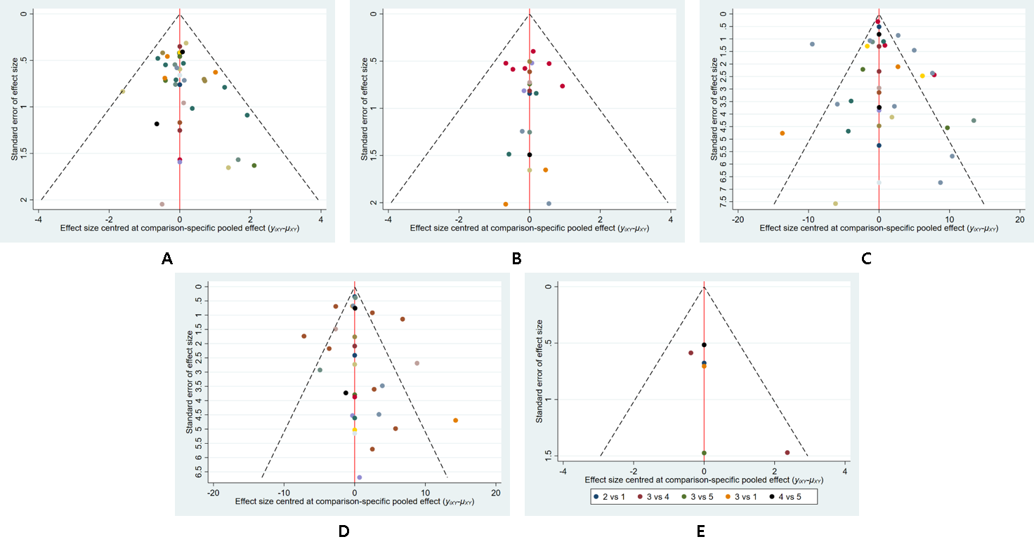
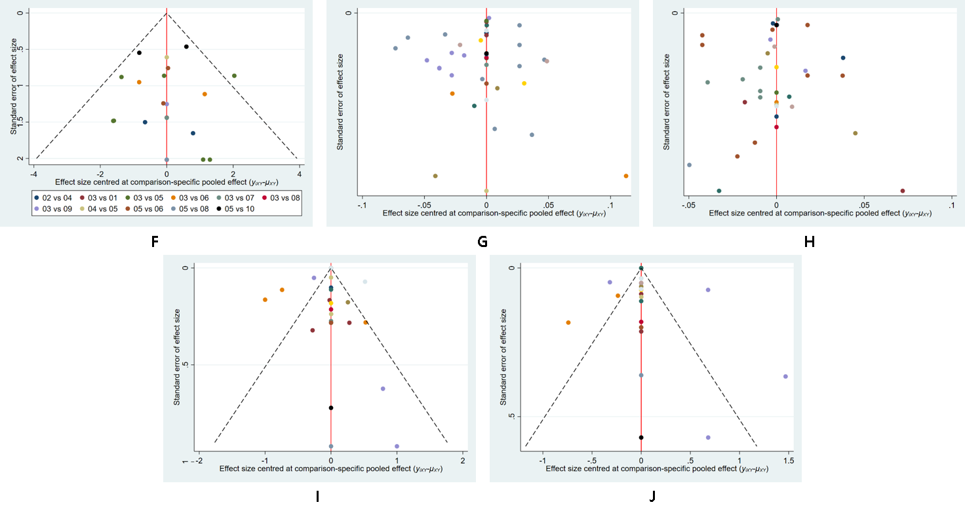
S8 Figure. Comparison-adjusted funnel plots. (A) Incidence of Hypotension, (B) Incidence of hypertension, (C) Minimum systolic blood pressure (SBP_{min}) (D) Maximum systolic blood pressure (SBP_{max}), (E) Incidence of tachycardia, (F) Incidence of bradycardia, (G) Umbilical arterial pH, (H) Umbilical venous pH, (I) 1 min Apgar score, (J) 5 min Apgar score.
10. SUCRA values

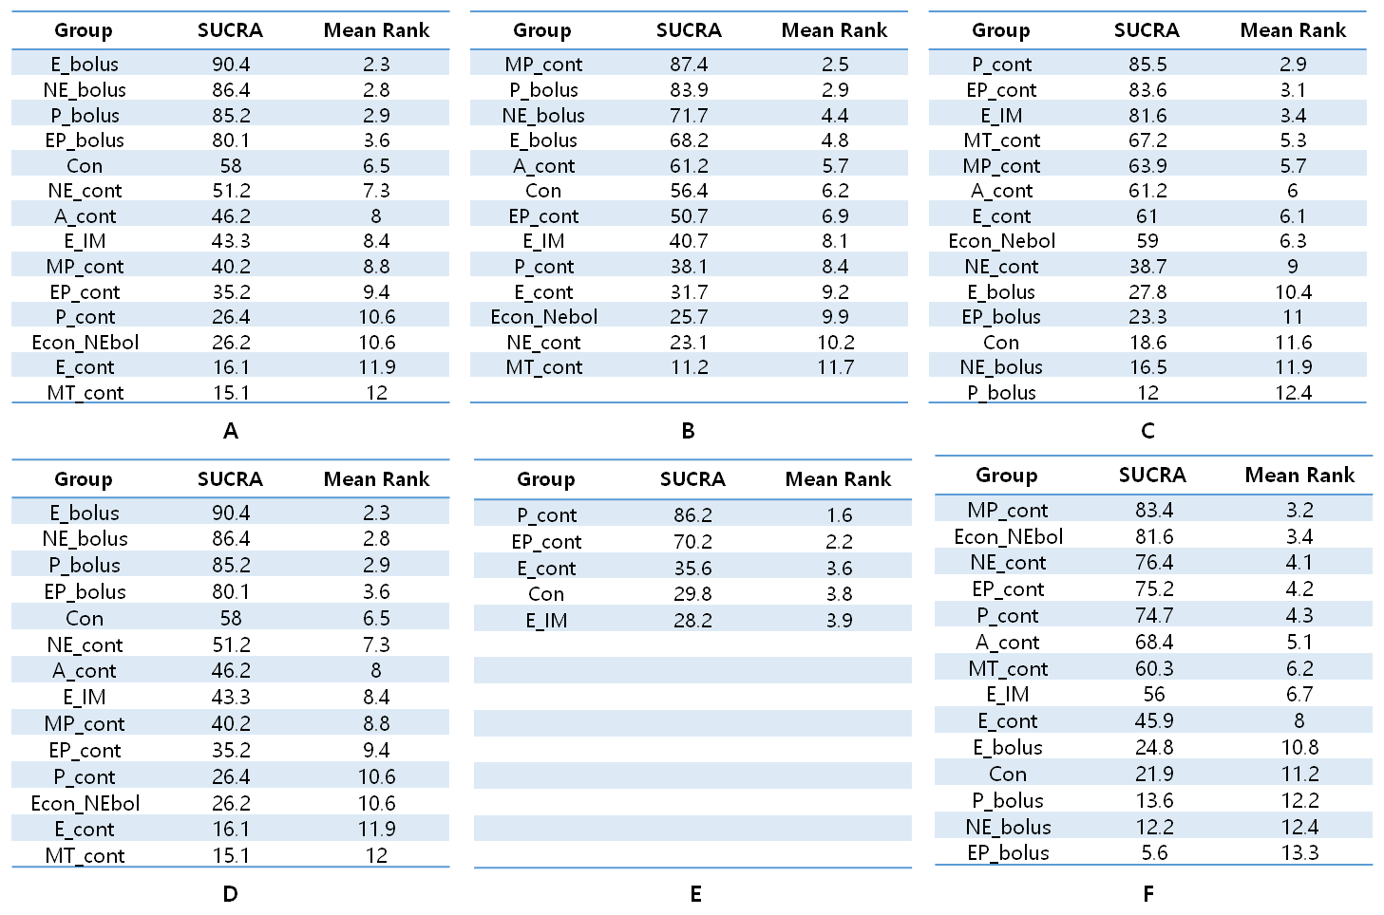
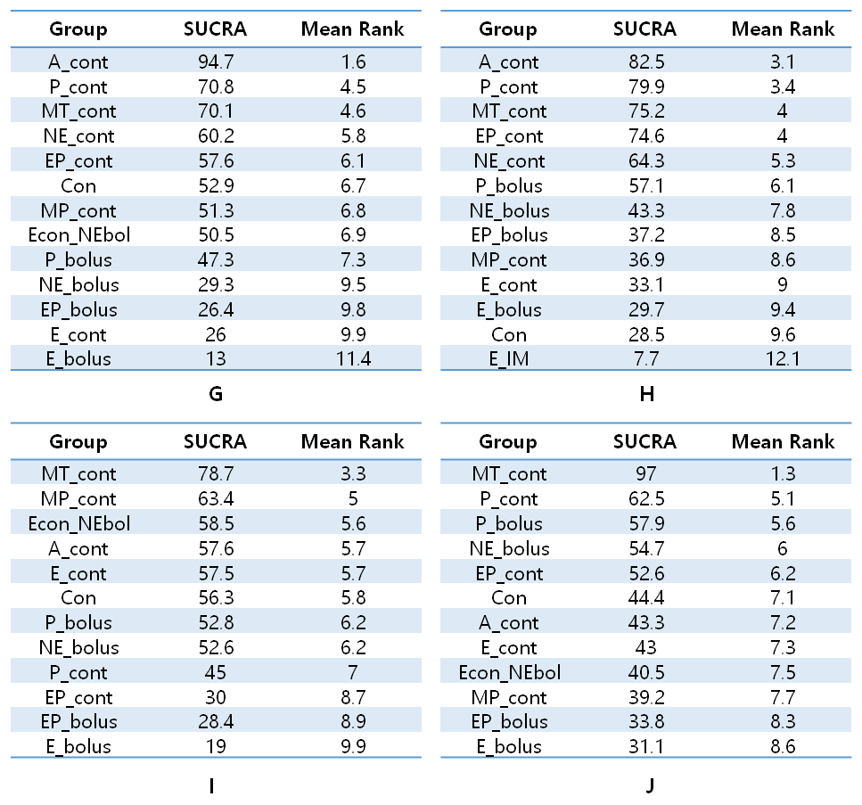
S9 Table. SUCRA values. (A) Incidence of Hypotension, (B) Incidence of hypertension, (C) Minimum systolic blood pressure (SBP_{min}) (D) Maximum systolic blood pressure (SBP_{max}), (E) Incidence of tachycardia, (F) Incidence of bradycardia, (G) Umbilical arterial pH, (H) Umbilical venous pH, (I) 1 min Apgar score, (J) 5 min Apgar score.
11. S10 Table. pH of umbilical artery and vein
Umbilical artery |  |  |  |  | Umbilical vein
Vasopressor | No. of study | 95% CI | I² | P_{chi}² | Vasopressor | No. of study | 95% CI | I² | P_{chi}²
Control | 4 | 7.264(7.235-7.294) | 84.0 | 0.002 | Control | 3 | 7.320(7.289-7.352) | 84.4 | 0.002
 |  |  |  |  | E_IM | 1 | 7.310(7.284-7.336)
E_bolus | 10 | 7.270(7.253-7.286) | 94.0 | <0.001 | E_bolus | 8 | 7.332(7.316-7.348) | 91.9 | <0.001
E_cont | 17 | 7.253(7.233-7.274) | 96.3 | <0.001 | E_cont | 15 | 7.318(7.301-7.335) | 97.8 | <0.001
P_bolus | 11 | 7.304(7.290-7.318) | 94.1 | <0.001 | P_bolus | 10 | 7.343(7.328-7.359) | 99.7 | <0.001
P_cont | 14 | 7.303(7.293-7.313) | 97.7 | <0.001 | P_cont | 13 | 7.346(7.336-7.356) | 99.0 | <0.001
EP_bolus | 1 | 7.240(7.196-7.284) |  |  | EP_bolus | 1 | 7.330(7.299-7.361)
EP_cont | 2 | 7.277(7.208-7.345) | 94.7 | <0.001 | EP_cont | 2 | 7.348(7.300-7.397) | 86.4 | 0.007
A_cont | 2 | 7.310(7.270-7.359) | 90.9 | 0.001 | A_cont | 2 | 7.350(7.339-7.361) | 0.0 | 1.000
MT_cont | 2 | 7.291(7.252-7.330) | 96.0 | <0.001 | MT_cont | 2 | 7.335(7.286-7.384) | 98.5 | <0.001
MP_cont | 2 | 7.296(7.247-7.345) | 88.1 | 0.004 | MP_cont | 2 | 7.344(7.328-7.361) | 0.0 | 0.552
NE_cont | 3 | 7.300(7.267-7.333) | 99.1 | <0.001 | NE_cont | 2 | 7.310(7.232-7.389) | 99.4 | <0.001
NE_bolus | 2 | 7.282(7.223-7.340) | 93.1 | <0.001 | NE_bolus | 2 | 7.332(7.253-7.410) | 95.5 | <0.001
Econ_NEbol | 1 | 7.320(7.312-7.328)

Abbreviations: E = ephedrine; P = phenylephrine; EP = ephedrine mixed with phenylephrine; A II = angiotensin II; MT = metaraminol; MP = mephentermine; NE = norepinephrine; No= number; CI= confidence interval; cont=continuous

